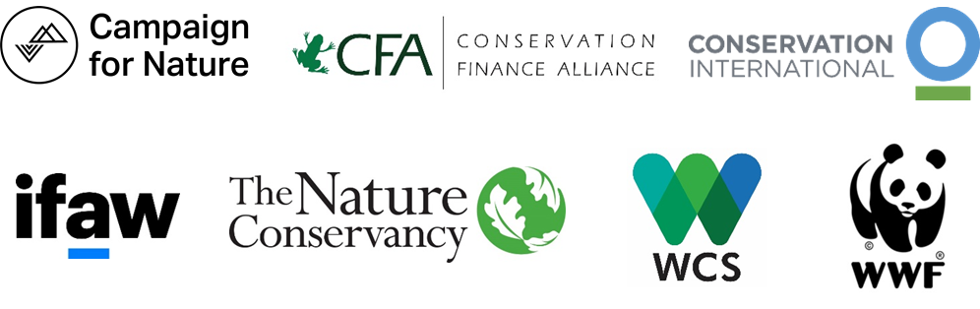
Global Leadership of Public Development Banks To Address Biodiversity Loss
We, a coalition of leading nature conservation NGOs, welcome the Joint Declaration of all Public Development Banks in the World and the International Development Finance Club (IDFC) Common Position Paper on Biodiversity following the Finance in Common Summit held on November 11th and 12th.
While the commitments made for biodiversity at the Finance in Common Summit are welcomed fundamental steps, we urge Public Development Banks to further reinforce their global leadership in order to effectively and operationally shift towards “nature positive” development finance. This will require phasing out investments in activities that have harmful effects on nature, strengthening the implementation of compensation schemes for the residual, unavoidable impacts on biodiversity caused by investments, and closing the gap in finance for biodiversity through quantifiable commitments. We stand ready to partner with Public Development Banks and contribute our scientific, policy and project development expertise to work together towards the common aim to protect and restore biodiversity.
Nature is flashing red warning signs of system failure. Next year in China, the 15th Conference of the Parties to the UN Convention on Biological Diversity will be a crucial opportunity to agree on a new shared framework to halt and reverse biodiversity loss. PDBs are in a unique position to influence the shift of financial flows and mobilise finance at scale toward activities that help—rather than hurt—nature.
PDBs should drive this shift in three fundamental ways:
1. Mainstream biodiversity in finance by:
- Strengthening and harmonizing existing do no harm principles to reduce, and ideally eliminate, investment practices that are harmful to biodiversity, in particular in agriculture, infrastructure, fossil fuels and companies and/or supply chains that are responsible for deforestation or the destruction of nature.
- Integrating biodiversity risk and impact analysis and reporting within investment decisions and developing common metrics and indicators by, for example, participating in the Task Force on Nature-related Financial Disclosures.
- Ensuring that infrastructure investments better consider biodiversity impacts by adopting integrated, large-scale spatial plans that identify important critical and natural habitats, avoid investments in such areas and ensure financial resources are committed to meet mitigation targets.
- Auditing and publicly reporting on the actual implementation of biodiversity and environmental standards, such as the generally adopted IFC Performance Standard 6, and the performance of PDB clients on these standards, including performance on financing and mitigating impacts.
2. Mobilize investments in nature by:
- Setting operational targets for biodiversity finance aligned with those agreed on at the upcoming UN Convention on Biological Diversity COP15.
- Providing de-risking, effective and coordinated financial tools such as grants and technical assistance throughout the life of a project; truly concessionary finance; and flexible investment terms to better attract private sector finance in nature at scale.
3. Support individual countries’ enabling environment for nature-positive investments by:
  - Increasing the use of multi-donor, policy-based lending programs, as effective tools to build government capacity and influence financing and implementation of National Biodiversity Strategies and Action Plans.
  - Meaningfully integrating the voices, rights and socio-economic interests of indigenous peoples, local communities and landowners within project development and investment decision processes right from the start.
Harmful investment and economic activities are causing unprecedented and accelerating loss of biodiversity and massive social, health and economic costs globally. To reverse the global loss of biodiversity, we all need to rethink and reset our relationship with nature and transform our economic models and markets. Public development banks, equipped with a public policy role and mandate and accounting for 10% of public and private investments globally, should actively contribute to this aim with the support of civil society organizations and other stakeholders.

